Technological Feasibility Analysis
GeoLearn
11/8/2019
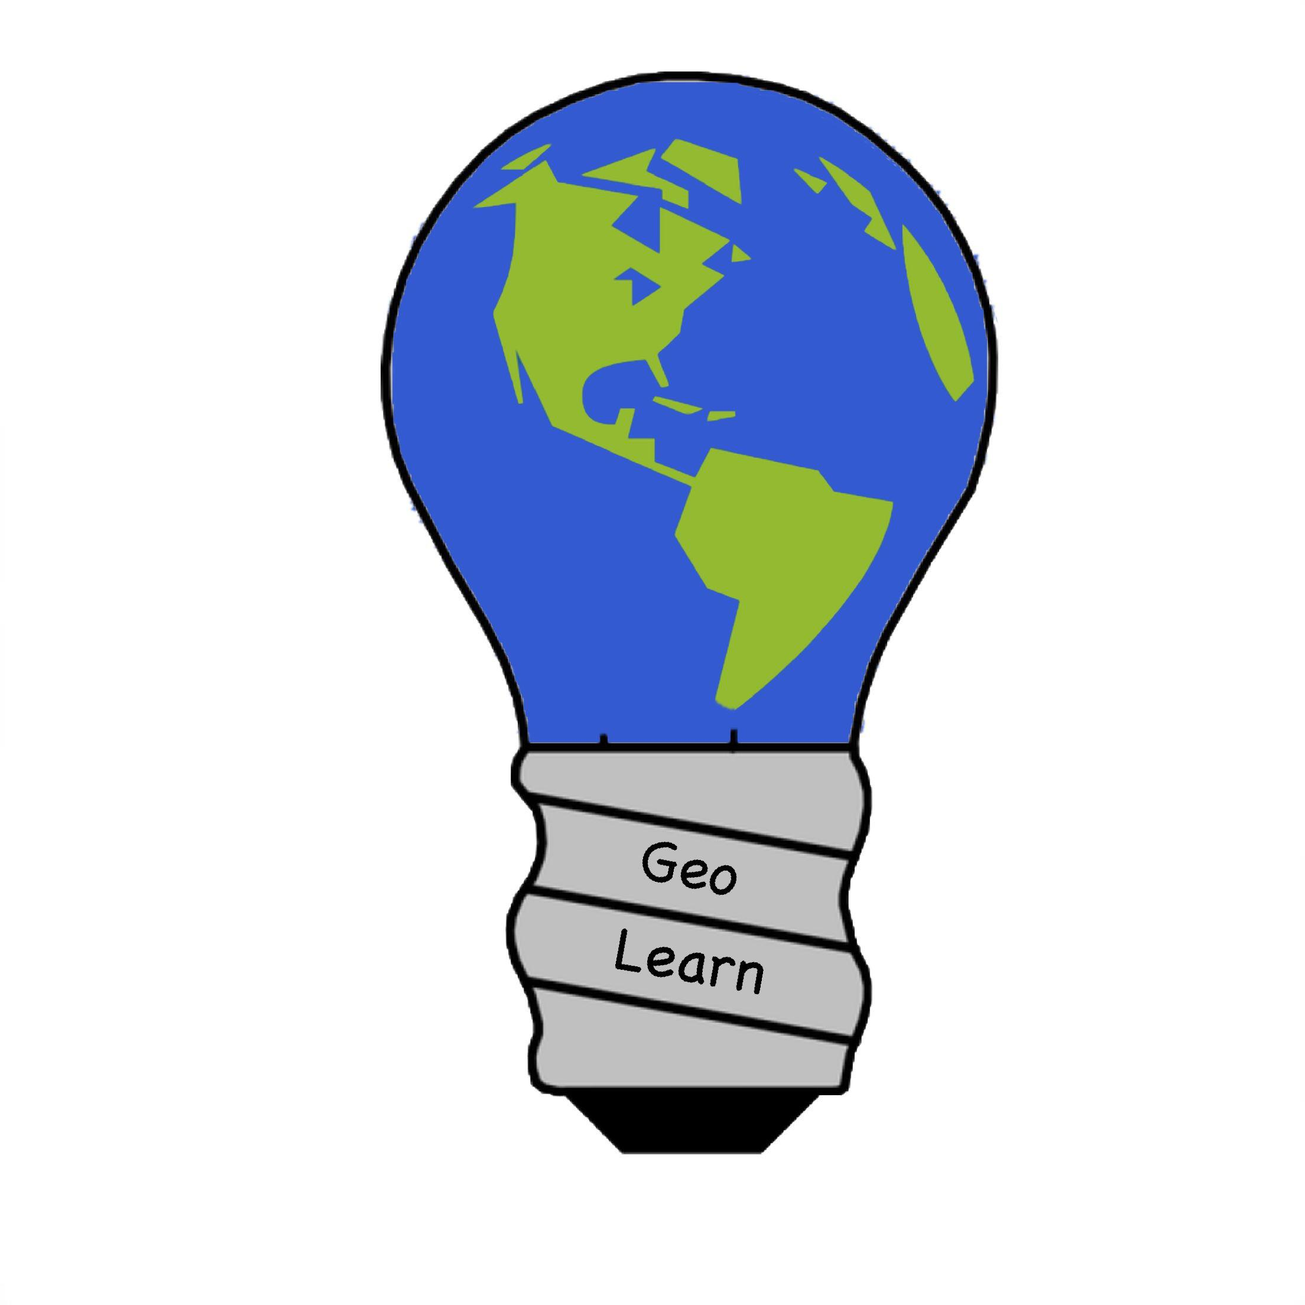

Mentor: Fabio Santos
Sponser: Dr. Chris Doughty
Team members: Samuel Prasse (lead), Kaitlyn Grubb,
Tyler Pehringer, Joshus Tenakhongva

Table of Contents
- Introduction………………………………………………………………………………p3
- Technical Challenges…………………………………………………………………….p5
  - Google Slides and Earth Engine………………………………………………....p5
  - Ecolocation Interaction…………………………………………………………..p5
  - Database Storage………………………………………………………………....p6
  - Accessibility……………………………………………………………………...p7
  - Development/Debugging Environment………………………………………….p7
- Technical Analysis...………………………...………………………....………………...p8
  - Languages..………………………………………………………………………p8
    - Python…………………………………………………………………....p8
    - PHP………………………………………………………………………p9
    - Ruby…………………………………………………………………….p10
  - Biodiversity Information Mapping…...…………………………………....…...p13
    - ArcGIS………………....……………………………………………….p13
    - Whitebox GAT…….…………………………………………………....p14
    - Conversion of Ecolocation Code……...………………………………..p15
  - Database Languages…………………………………………………………….p17
    - SQL……………………………………………………………………..p18
    - Oracle Database………………………………………………………...p19
  - Application Types…....…………………………………………………………p21
    - Desktop Application…………...…………………………………….....p22
    - Web Application……….……………………………………………….p23
    - Mobile Application........………………………………………………..p24
  - Integrated Development Environment……….…………...…….……………....p26
    - IntelliJ IDEA…………………………………………………………....p27
    - Aptana Studio 3…………………………………………………....…...p28
    - PyCharm………………………………………………………………..p29
- Technology Integration………………………………………………………………....p32
- Conclusion……………………………………………………………………………...p33
- Resources……………………………………………………………………………….p34

Introduction
We are team GeoLearn and our goal is to improve elementary education with custom online environmental science lectures. GeoLearn is composed of undergraduates Samuel Prasse, Kaitlyn Grubb, Tyler Pehringer, Joshus Tenakhongva under the guidance of Fabio Santos. Educating children about global issues such as climate change and animal extinction is important for the future of humans; however, it is hard for teachers to convey such issues to young minds. On top of that issues like climate change are heavily driven by data collected by scientists who spend a lot of time sifting through data. Most elementary, middle school, and high school teachers do not have training to be able to gather this data and transform it in a way that will make sense to their students.
Let's look at Google Earth Engine to get an idea on why teachers do not have the skills to access data. As displayed on their website, “Earth Engine is a platform for scientific analysis and visualization of geospatial datasets, for academic, non-profit, business and government users.” They store data collected from satellites and provide access to years of this satellite data. Sara Aparício, a young graduate trainee at the European Space Agency, speaks on the issue of satellite data collection explaining “by the end of 2017, the operational Sentinel-1, -2 and -3 satellites alone will continuously collect a volume of 20 Terabytes per day” (Aparício) Google Earth Engine has data for multiple satellites that have been in orbit for more than 20 years.
How do teachers currently gather this data? They do not. They rely purely on material already provided by the book, which is gathered by trained professionals. As shown in figure 1, to access any of the stored satellite data a piece of code with various variables and commands is entered into Google Earth Engine. This data comes back as a list of numbers hardly meaningful to any human. In order to transform that data into a graph or picture more coding and graphical design is needed. Our sponsor, Dr. Chris Doughty, would like teachers to be able to easily access data and to be able to easily transform this data in a way that elementary, middle school, and high school students can understand and learn from.

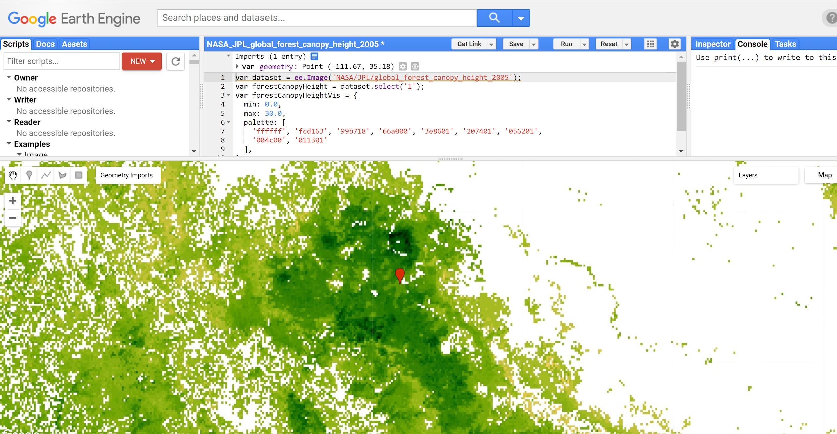
Figure 1: This is a picture on how data can be accessed from Google Earth Engine. This data set shows global forest canopy heights in 2016. The red pin is where Flagstaff Arizona is and this maps the area around Flagstaff.

Dr. Doughty has his Ph.D in Earth System Science and has been researching for over 15 years. Accessing this satellite data is fast, smooth, and straight forward for him; however, he recognizes this data is important for the education of young children. In order to make this data more accessible to teachers Dr. Doughty has asked our team to develop software that can access this data, transform it into a slide show based on school level, location,and topic, and then give teachers access to these slides.
We begin in the Technological Challenges section by analysing the major technological challenges we expect to encounter throughout developing our system. After that we begin our Technology Analysis where we then analyze each of these areas carefully in turn, looking at different tools to solve these issues, how we explored these tools, and rationale for choosing a particular tool over alternatives. In the Technology Integration Section, we then explain how all these tools work together and expected tool conflicts and workarounds.

Technical Challenges
We anticipate dealing with multiple issues during the development of GeoLearn. In this section we outline the technical issues of key features of GeoLearn. These issues will decide what technologies we use to help solve these problems.

II.A. Google Slides and Earth Engine Interaction
One of the more interesting challenges we are facing is the logistics of implementing information and visuals from Google products such as Earth Engine into our web application. We will need to write code to locate a specific area in the world, pull data displaying the effects of climate change, biodiversity, land use, and fire in a localized area over time. The next step is transforming that data into a useable format such as a GIF or video file that can be easily implemented into a Google Slides presentation. While the main challenge with this is designing a method to pull and display data, another challenge lies in making this data easily understandable for students. The goal is to ensure the data is presented in a way that will impact the student and begin a thought process about what is happening in their environment. A possible solution to the problem is to find a programming language that can be implemented with the API format of Slides and Earth Engine. There are several options such as Python, PHP, and Ruby.

II.B Ecolocation Interaction
Ecolocation was a Capstone project created a few years ago to educate the user on what types of mammals lived in the area they are searching for. This application is based on Android OS and is unique because of its ability to locate and describe mammals that used to live in an area but are now extinct. Our challenge is to implement the code from Ecolocation into GeoLearn. We are hoping to implement the code in such a way that allows the team to include relevant animal information into the slides of our GeoLearn presentations based off the user’s location. The database information from Ecolocation could also provide opportunities for specialized quizzes and activities for students to complete once the lesson has been taught. There are several methods we could accomplish this task with software such as ArcGIS, Whitebox GAT, or converting the Ecolocation code to fit our system.

II.B Database Storage
It is one thing to allow easy interaction between the application and the user, it is another to make sure the user information is secured. Companies face this issue everyday and for the most part, it can be rooted back to poor database management. One of our goals is to make a secure database, that is also easy to access by the applications users. In order to accomplish this, we need to cover these different challenges:
- User Data Storage: We need to be able to save every users information (UserID, Password and Email for the teachers). We need to make sure that the database stores this information so that at can be managed easily by the admin. We will need to find a secure server space to ensure we can store user data properly
- Presentation Data Storage: We need to be able to store any generated presentations. These presentations must be sorted by topic and age level they are tailored for. Users must be able to store any outside files besides the presentations. They must be stored in the same way as the presentations themselves. Both the presentations and the files must have a saved average rating for them. This rating will only be changed based on the ratings given by the teacher users.
- Quizzes: The quizzes must be stored in the same way as the presentations; they must be sorted by topic and age group. The quizzes must also have an average rating saved to them; the ratings will be given by the student users.
- Security: We also need to ensure that our users' data is secure. The database needs to have a secure user login and well as being able to store that login information. We need to make sure the only person that can manage this information is the admin. We also need to make sure that our method of security agrees with OAuth 2.0 flow, which would allow us to properly store Google API information as shown in Figure 2.
In order to accomplish these goals, we need to have the proper database language, as well as the proper server space to handle all of this information.

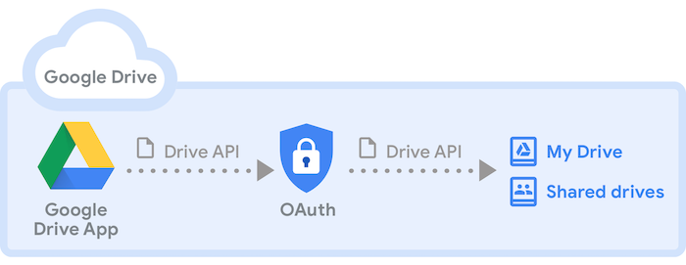
Figure 2: This is a picture on how the Google Drive API is used and how it interacts with OAuth authentication to access drives. (“Introduction to Google Drive API”)

II.D Accessibility
Because GeoLearn is being developed for teachers to use in classrooms, accessibility is an important challenge GeoLearn needs to achieve. Teachers need to be able to access GeoLearn both at home and in the classroom in order to plan and present slides. In addition, GeoLearn will allow students access to GeoLearn outside and inside the classroom to view slides, watch more informational videos, and play with interactive pages linked into the slides. GeoLearn also should have room to expand to different platforms so that both teachers and students can access the software outside of school and home.

II.E Development/Debugging Environment
When developing any codebase meant to be extended and maintained by future folks, good documentation, readability, and low coupling are invaluable. It’s also important to have a solid environment for catching any syntactical and functional issues in the code. Ensuring that the Integrated Development Environment (IDE) is suitable for our purposes can make these tasks easier to implement. Our priorities when deciding what IDE we want to use are as follows:

- An abundance of text editing features: Ease of editing text throughout the codebase and making simple edits change the code consistently and properly. We want to reduce typos and syntactical errors, and we also want to make correcting them as simple as possible.
- A robust debugging environment: Debugging that will allow us to test our code to find as many bugs as we can find to ensure maximum functionality.
- A fair learning curve: As we only have a few months to complete this project, our priorities lie with learning the other technologies we’re using such as the Ecolocation database, the language, and web tools. We should not dedicate a lot of time to learning the IDE.

Proper documentation and readability is a time-consuming issue, but not a particularly difficult one. Whatever means we can use to reduce the time needed to create good code will be very useful.

Technical Analysis
In order to solve the problems in the previous section, Technological Challenges, certain tools will be used to help build our project. In this section tools are rated on a one to five scale in categories that are specific for that technology. This score chart along with outside factors are used here to provide knowledge on why and how GeoLearn chose this given set of tools to help build the software.

III.A Language
Arguably one of the most crucial aspects of developing a software product, the language selected by a team will define the extent of an applications capabilities as well as its limitations. In this section we will be reviewing several powerful languages with the ability to provide us with a high-level web application capable of satisfying all requirements necessary for the project. These languages include Python, PHP, and Ruby.

III.A.1 Python
Python is one of the top choices for our team because of the Django REST framework. The DRF has some of the most extensive documentation of Django frameworks. DRF was built specifically for building API’s and provides the programmer with a way to connect multiple platforms to one API all under the same logic. This means if we were to update something on the web application or add more functionality, we would only need to change it on one side, not on each platform. Another plus of using Python in our implementation is that it is an easy to learn language and the team has several years of experience developing it.

Readability
Python is the most readable programming language in our list of options. While it has some drawbacks such as no semicolons to determine where the end of the line is, the function definitions and overall design of a Python program is simple to read and understand.

Learning Curve
All members of our team have around four years of experience programming in Python. This language was the first one we learned at Northern Arizona University and provided us with a fantastic basis for future programming classes.

Documentation
With Python 3.8.0 (the newest version as of 10/21/19), all necessary documentation can be found online. The information is organized by Tutorials, Library References, Modules, and API’s. This language has an enormous amount of support backing it.

Tools for UI Development
Python has an enormous amount of GUI frameworks available. The team has access to a traditional one such as TkInter or more platform specific ones which would be beneficial for the development of the web application.

Conclusion
In conclusion, Python is the best overall language for our project because of its readability and UI development tools. The Django framework is one of, if not the best tool for developing web applications and it is built using Python. This means seamless transitions between our API’s and a very high rated “Ease of Use”.

Language | Readability | Learning Curve | Documentation | Tools for UI Development
Python | 5 | 5 | 5 | 5
scale of 1-5, 5 being very readable, having easy learning curve, having a large amount of documentation, having many tools for UI development

III.A.2 PHP
PHP is another option of programming languages to build our system with. It is a relatively simple language to learn but the team has minimal experience programming in this language. However, PHP does contain a framework known as Laravel. It is a PHP framework that requires a program called Composer to be installed and handle the dependencies and libraries of PHP. This is an extra step that we do not need to perform when using a language such as Python. Laravel would assist in database design but PHP would not be our number one choice for development.

Readability
PHP is a programming language which is heavily integrated with HTML and has been used in web development for many years. While not as easily readable as Python, PHP is a familiar looking language and would be considerably readable to our team and other collaborators.

Learning Curve
Our team has very minimal experience in PHP, therefore we would have to take more time to learn syntax and ensure that we could build the highest quality product as possible rather than with a language such as Python.

Documentation
One of the benefits of PHP is how well documented it is. The site containing the documentation could cause issues for someone trying to find a document or process that they are not familiar with but the information is there. The docs will be downloaded as a tar.gz file which will have to be extracted by the user.

Tools for UI Development
In our research, I found very few reputable user interface building tools but ones such as Agile Toolkit had extensive documentation and would not be too difficult to implement an attractive looking UI.

Conclusion
PHP would be a decent choice to design our web application in but there are much better options for our team and client. The frameworks are not up to our standards and learning the syntax of the language would take time the team does not need to invest.

Language | Readability | Learning Curve | Documentation | Tools for UI Development
PHP | 3 | 2 | 4 | 2
scale of 1-5, 5 being very readable, having easy learning curve, having a large amount of documentation, having many tools for UI development

III.A.3 Ruby
Ruby is a dynamic scripting language which contains a web-development framework Rails. Rails provides the programmer with ease of use similar to the Python framework Django. Rails has secure login to Google account in two lines of code, built-in CAPTCHA, and other authorization tools which are vital to this project. A downside of programming in this language is the lack of experience from our team in developing in it. The code is also very robust and at some times, hard to decipher what is happening without a plethora of comments. While writing our application in this language would require a large learning curve, we believe that Ruby is one of the top choices of programming languages to complete this project.

Readability
Ruby is an interesting language because it treats everything as an object. It assigns a method and instance variable to all of its types. Variable declarations are fairly simple to read and understand but more intensive code such as the programs we will be writing will become confusing.

Learning Curve
Aspects of the language such as it’s strict object orientation make the language very different and would require quite a bit of time devoted to learning syntax. The team has very minimal experience in Ruby, a majority of us have not written a single program in the language.

Documentation
Ruby has an excellent database of documentation. It is similar to Python in that it has sectioned off, easy to read headers for every section of documents. It provides the user with several tutorials and basic programming assignments to get the feel of the language.

Tools for UI Development
Ruby has many frameworks for developing a user interface. Some of the more popular ones such as Shoes3/4, and FXRuby all received good grades from industry professionals, however, Shoes lacked a good amount of documentation. Ruby on Rails would be our most valuable tool if we were to design in Ruby.

Conclusion
In conclusion, Ruby would be a great choice to build our web application for Dr. Doughty. The issue lies in the team having very minimal experience in the language and the syntax being so drastically different from what the team is familiar with.

Language | Readability | Learning Curve | Documentation | Tools for UI Development
Ruby | 2 | 1 | 5 | 5
scale of 1-5, 5 being very readable, having easy learning curve, having a large amount of documentation, having many tools for UI development

Our Approach
The team has decided to program using the Django framework, writing in the Python programming language. This decision was reached because of the ease of use associated with the Django REST framework, as well as the readability of Python code. This, along with comments, will make our code read like a book rather than a computer program, therefore letting anyone with any experience level understand what is happening in the code.

Language | Readability | Learning Curve | Documentation | Tools for UI Development | Total
Python | 5 | 5 | 5 | 5 | 20
PHP | 3 | 2 | 4 | 2 | 11
Ruby | 2 | 1 | 5 | 5 | 13
scale of 1-5, 5 being very readable, having easy learning curve, having a large amount of documentation, having many tools for UI development

Why this solves the API challenge
The web application we are building requires a modern and sleek design with a high level of usability. Our hope is that educators of all ages and grades will be able to use our application, and the most effective language and framework to accomplish that is with Python. The Google Slides and Earth Engine API’s have examples and methods built-in and written in Python. This accompanied by the Django framework will make developing the web application considerably more efficient because of the similarities between the two. Django will allow the team to port the code from the Google API’s and begin developing the skeleton of the slideshow presentation much quicker compared to Laravel through PHP or Ruby on Rails. PHP and Ruby are far more complicated languages and their frameworks for web development reflect that. Many of the tools provided in the PHP framework Laravel will not be able to accomplish what we need to create in the time we need to create it in. We have a very strict time limit when designing this project and ease of use is one of our top priorities. For these reasons, we will be writing our web application in Python using the Django framework.

Testing Feasibility
Now that we have chosen our process for interaction between Google Slides and Google Earth Engine, we will continue reading through documentation of the Django API tools and develop several demos which will be a great visual of how the slides will be created. These demonstrations will be given to our project mentor, and project sponsor in a way that everyone on the team will know how the code is working and what each line is affecting. These will be presented in the coming weeks of Capstone.

III.B Biodiversity Information Mapping Software
One of the most important pieces of our custom slideshow presentations is our ability to present information in a meaningful way such that students will not only retain the information, but retain it in a way that it will have an impact on them. The information we will convey covers many topics such as climate change, biodiversity, and land use change. This information has not been available to view with such ease before our project. This section will discuss three different approaches to creating visuals of data vital to the future health of our planet.

III.B.1 ArcGIS
ArcGIS is a cloud-based software service which would allow the team to create both two-dimensional and three-dimensional maps of the geolocation of our users. The developer version of this software is pre-loaded with the world’s largest geospatial content library. They have thousands of basemaps and datasets to be implemented into our project. ArcGIS provides students with an interactive look into what the area around them looks like currently and how it has evolved into that state. All the data and code that we write can be easily stored in the cloud and behind a firewall. The team has access to all the data and can manage it securely. The site has plenty of documentation so the learning curve will be significantly less than a similar software.

Ease of Use
ArcGIS is the premier Geographic Information System software. It allows users to create maps by dropping in spreadsheets data and take full advantage of their Smart Mapping styles to make the data as visually pleasing as possible. This software is the prime choice for our web application.

Cost
The team would ensue no cost for this software.

Documentation
There are multiple websites dedicated to using ArcGIS and all of them provide many graphics and code examples. The company that developed ArcGIS, Esri, has documentation on how to use their cloud based servers as well as firewall services.

Conclusion
ArcGIS is an incredible software that meshes perfectly with data from Dr. Doughty’s lab. His team has large amounts of files that can easily be translated into interactive maps and could very easily find a home in our web application.

Software | Ease of Use | Cost | Documentation
ArcGIS | 4 | 1 | 5
*on a scale of 1-5, 5 being very easy to use, having a very high cost, having a lot of documentation

III.B.2 Whitebox GAT
Whitebox GAT or Geospatial Analysis Tools is a piece of open source software designed as a desktop GIS and remote sensing software package for general applications of geospatial analysis and data visualization. The software is packaged with a button that allows the user to press a button and view the source code associated with each tool. This eliminates the user from having to download enormous source code files and dig through them to find out what is going on behind the scenes. The learning curve would be relatively big with this product however because the team would have to learn how to program and develop GIS code and translate that to our project. The benefit of this software is that it is free and allows for manipulation that may very well be necessary to fit to the GeoLearn project.

Ease of Use
Whitebox is one of the more interesting software programs we researched. It is strictly open source and fairly recent in terms of its updates. This program would result in more work for the team because none of us have worked in it before.

Cost
The team would ensue no cost for this software.

Documentation
There was not a large amount of documentation for Whitebox. The software is open source and provides the users with the ability to examine the code for a specific process. This attribute is helpful when examining unfamiliar software.

Conclusion
Whitebox is a very useful tool but would not provide the team with the level of performance necessary for our project. We would have to perform a lot of the legwork ourselves, while it is already done in ArcGIS.

Software | Ease of Use | Cost | Documentation
Whitebox GAT | 2 | 1 | 3
*on a scale of 1-5, 5 being very easy to use, having a very high cost, having a lot of documentation

III.B.3 Conversion of Ecolocation Code
The most cost effective and simple solution would be to convert the previous Ecolocation code into a more uniform language for our project and then embed the application into GeoLearn. The benefit of doing this is that we already have a working prototype and a database full of information that would greatly improve our generated presentations. The visuals of Ecolocation would not be as impressive as ArcGIS but it would benefit older students more so than younger ones because of the lack of visuals in the application. If we were to use the original code from this project, we receive the added benefit of visualizing where and when extinct mammals lived in specific areas. This adds an element of information that is not as easily and readily available anywhere else.

Ease of Use
Ecolocation is a project developed by a previous capstone team which we have to opportunity to include in the GeoLearn web application. Translating the previous teams code to fit out application would be relatively simple. It would take a bit of work but the information has already been stored in a database and is readily available. Our team would have to port the code into our Django system.

Cost
The team would ensue no cost for this software.

Documentation
There is very little documentation for the code aspect of the Ecolocation project. The group created a document which gives a rough outline of the project and how it is set up but gives no insight into what language(s) the project was written in. This gives a bit of a challenge but converting the code is always a good option because of how closely Dr. Doughty’s team worked with the group who created Ecolocation.

Conclusion
Software | Ease of Use | Cost | Documentation
Code Conversion | 3 | 1 | 3
*on a scale of 1-5, 5 being very easy to use, having a very high cost, having a lot of documentation

Our Approach
The method we have chosen to go with for our data visualization is with the software ArcGIS. This program will allow us to create unique and attractive looking maps and data visualizations which are vital to capturing the attention of younger students. The cloud-based storage system that ArcGIS offers as well as the security aspect of the software make it difficult to beat in terms of what it can do.

Software | Ease of Use | Cost | Documentation | Total
ArcGIS | 4 | 1 | 5 | 10
Whitebox GAT | 2 | 1 | 3 | 6
Code Conversion | 3 | 1 | 3 | 7
*on a scale of 1-5, 5 being very easy to use, having a very high cost, having a lot of documentation

Why this solves the Ecolocation challenge
GeoLearn is committed to providing students with the very best in terms of information presented to them. For younger students especially, visual learning is one of the most important aspects of their process. Many are not fluent readers yet and would struggle with a higher level slideshow containing mostly words. The software best equipped to provide our team as well as the students with the best possible experience is ArcGIS. This software is very powerful in the way that it can create three dimensional maps based on data we input. The data from the Ecolocation application can now be implemented using ArcGIS to create more creative maps that capture the attention of students and will be interesting for them to explore on their own. It has many features that will benefit the team and the students we are creating it for. The other two methods, Whitebox GAT and our plan to convert the code, do not have nearly the amount of abilities at ArcGIS, making this software the clear frontrunner.

Proving Feasibility
Now that we have determined the software we will be moving forward with; the team will be working with ArcGIS to create demonstration models to be presented to the Capstone sponsor Dr. Chris Doughty. He and his team have experience with these types of files so we will be obtaining a few source code files and converting them to work in the way we intend them to in the final project. This will ensure that ArcGIS is the right fit for the GeoLearn project.

III.C Database Languages: Solves Data Storage
The following is a detailed list of different potential database languages we can utilize for proper data storage. This is important, because many database languages are used for a specific purpose. We need to make sure that the admin will have an easy time managing any information stored. We will be looking for:
- How well documented it is. The better the documentation for the language, the better we can understand what works best to ensure that our database is fully functional to our needs. We will be able to plan out any potential obstacles we might face with the language so that we can better understand how to overcome them.
- How well the language can organize the data. We need the language to make the information easy to manage for the admins. It needs to ensure the data does not get lost and that we do not misplace any form of information given to the language.
- How well it interacts with our server. This means we need to make sure that the database will be easily transferred to the server. The server will ensure that all of the information given to it will be secure. If the server was not able to read the language we are using, then we would have no security for the data we are trying to store. This also implies that we might need to look at different server spaces.

III.C.1 MySQL
MySQL is one of the most well known database languages. It is widely used in almost every program or application created today. It is a free to use language that comes with its own IDE that allows for fast and easy debugging. MySQL is used by major companies, such as Google, Skype and DropBox. In terms of the learning curve, those that have taken the introduction course for databases will have interacted with MySQL. It may be considered to be an entry level language, however it is very versatile. It has great documentation which allows developers to learn the language with ease. Not only that, but the application Ecolocation already uses MySQL for their own database, which we can potentially use for our own database. It has many different organization methods for use to utilize. This language can also be a potential candidate, because it is compatible with the server base AWS, which is what our client would like us to use.

Documentation
MySQL is well documented for anyone that wants to learn how to interact with a database. Based on the skill of the group, it might be moderately easy to use this language since some of us have taken a class that have taught us the basics of this language. The application, Ecolocation, will also have documentation on how their database works, allowing us to easily integrate their stored info into our database.

Organization
MySQL has a vast amount of different tools to organize the data we need. It is able to set UserID length and conditions as well as password length and conditions. We can set up an algorithm to keep track of the average rating for presentations, files and quizzes. We would be able to store an unlimited amount of user information and allow admin access so that they can easily manage the data incase there needs to be any major or minor changes.

Server Interaction
We need to be able to save all of our user info on a server. Luckily, MySQL has many different database management tools that can connect to AWS servers. Since it works well with each other, we can ensure that the security for the user info.

Conclusion
MySQL can be useful to us, considering that one of the projects we are utilizing uses MySQL for their own databases. Not only that, but we need to consider that MySQL works well with AWS servers, which is what the client is hoping to use.

 | Documentation | Organization | Server Commun.
MySQL | 4 | 5 | 5
On a scale from 1 - 5, 5 being the best to use, the best organization and the best for server communication.

III.C.2 Oracle
Oracle is a versatile language that can be used for full database control. It is purely a cloud based database language, which can be potentially cost effective for our project. Oracle is compatible with AWS as well, meaning it is a legitimate candidate for our project. Though it does have a sizeable amount of documentation, none of us are really familiar using it. Oracle is used throughout major companies alongside MySQL. It is most secure when it is being used on Oracle servers, which we might not be able to able to use for this project.

Documentation
Oracle consists of many different programming languages, such as C, C++ and Python. Though we have all had interactions with these languages before, understanding how to interact with Oracle services would be new to all of us. There are a lot of different documentation for us to use, however, such as data security and architecture. Oracle shows users how to connect their stored data to any outside server, such as AWS, but we will get into that when talking about its server connectivity.

Organization
Oracle has many different services and methods that allow users to store any amount of data fast and efficiently. Oracle allows for easy to understand mapping of an application's database which would allow the admin to navigate different portions of data with no issue. Since Oracle utilizes different programming languages to create different databases, which can give us more freedom to arrange data as we please.

Server Interaction
Though Oracle does have connectivity with AWS, it works at its best if we are able to stick to the base Oracle server in terms of security.

Conclusion
Oracle is a viable option for us to use in terms of organization and server interaction, but we might have trouble when it comes to truly learning how to utilize it. We will need to worry about security when it comes to using AWS, which is what the client wants us to use.

 | Documentation | Organization | Server Interactions
Oracle Database | 3 | 5 | 4
On a scale from 1 - 5, 5 being the best to use, the best organization and the best for server communication.

Our Approach
We will be using MySQL for the creation of the database. This is because it is versatile for AWS and the application Ecolocation already uses it in there database. We want to ensure consistency between the two , so that data flow can be easier. MySQL works great utilizing different Google APIs, so that means we will be able to pull amy files we need from both the Google Earth Engine and Google Presentations.

Database Languages | Documentation | Organization | Server Interactions | Total
MySQL | 4 | 5 | 5 | 14
Oracle | 3 | 5 | 4 | 12
Scale 1- 5; 5 being well documented, well organized and has the best server interaction.

Why this solves the Data Storage challenge.
With this in mind, we can ensure that we can store all of the presentation information as well as the quizzes for the teachers and the students. MySQL would be able to handle any form of organization that is required for us to implement. We will be able to save the ratings given to these files and we will be able to let the admins manage this data to ensure we have no loss or tampering within the data. This is where the server space AWS comes in, this will allow us 24 hour security for free with 24 hour on call support in case there is an incident. AWS works the best in terms of data transfer and interaction with MySQL, so we can expect full protection of our users data, with minimal to no complications.

Testing Future Feasibility
In order to test MySQL, we need to check to see how well its tools and methods can organize user and presentation info. We will send example info to test the info retrieval of MySQL. Once we send the info successfully, we will make sure that the information given to us is well organized. We will then try to send a test from Ecolocation’s database, by giving a small snippet of data from that application, to see if both databases could interact with each other. We will then test to see if MySQL can successfully store information on AWS, by sending the same test data through to the server.

III.D Application Type: Solves Accessibility
As reported by Margaret Rouse “an application, also referred to as an application program or application software, is a computer software package that performs a specific function directly for an end user or, in some cases, for another application” (Rouse). Application type is an important development decision because it decides the basic structure the application can have. We need to consider how the software is downloaded and accessed along with how long the software will remain functional. It is also important to analyse how easy the updates can be distributed and if the application can access the internet or communicate with other pieces of software.
We will analyze 3 main application types: desktop, web, and mobile. It is important to closely look at each of the three application types because they will affect our technological decisions in the following sections. There are four important metrics when considering which application type to use:
- Accessibility determines how easy it is for users to get the software.
- Maintenance is how much time or how many blatant issues will occur when updating the software.
- Compatibility describes how easy it is to transfer from one platform/computer to another.
- Life cycle is a measure of how long the program will live without maintenance.

These categories will determine the application type GeoLearn will have. Because this program will be built to use in schools it is important to make sure the program is accessible to every school and teacher that wants to use it. Updates have to be smooth and not disruptive. GeoLearn will not need compatibility but it would be nice to have that option in the future. Lastly, life cycle is important because we do not want the upkeep of the system to cost too much money if regular updates or server upkeep is required.

III.D.1 Desktop Application
By definition a desktop application is a standalone application that is installed on a desktop or laptop computer. According to Shelley Elmblad, for most desktop software “some features in the software may be limited or unavailable without access to an internet connection,” but the whole application should be able to run on its own without the internet (Elmblad). Good examples of desktop software includes Microsoft Word, Paint, and Photoshop.

Accessibility
In order to access desktop software you must download the program off of an external device such as a CD or USB drive. Desktop software can also be accessed by a one time download off the internet. Desktop applications cannot be reformatted to be put on mobile devices and must be specifically remade to become a mobile application. This means that access would be limited to desktops with the software already downloaded onto it.

Maintenance
Because desktop applications are a one time download, updating the software is difficult. New versions can be released and development teams can notify the users of a new version. This creates multiple issues. First, this allows users to be using multiple versions at the same time. This will cause slide synchronization issues between users. Second, since this project is for schools, updates will have to wait until the school has approved the software.

Compatibility
As discussed in the accessibility section, desktop applications are not compatible with other application types and must be specifically remade to become a mobile application or web application.

Life Cycle
Desktop applications do not rely on servers. Most desktop applications do not rely on any external software; this makes desktop software’s life cycle extremely long. Because of this encapsulation, the life cycle increases due to not relying on the life cycles of servers and other applications.

Conclusion
Over all, desktop applications are extremely viable if the software is not going to be updated, offline, and has data that does not need to be translated between computers and devices. Desktop applications lack in compatibility and maintenance. This further supports a system that will not develop any more or evolve.

 | Accessibility | Maintenance | Compatibility | Life Cycle
Desktop Application | 2 | 1 | 1 | 5
*on a scale of 1-5, 5 being very accessible,easy to maintain,very compatible, and a long life cycle

III.D.2 Web Application
Margaret Rouse describes a web application as “an application program that is stored on a remote server and delivered over the Internet through a browser interface” (Rouse). This means web applications can be accessed without a download by anyone who has access to the internet. This also allows users to access the same version of software unlike desktop applications, which require users to have their own separate versions.

Accessibility
Because web applications are stored on remote servers, anybody with internet access can access the website if the server is up and running. All users will see the same version of the website and because our project will be used in schools all users should have internet access and a computer to access the website on.

Maintenance
Maintenance for web applications have a small cost. In order to update you must take the site offline for a little bit, update the server or software, and then put the site backup online. Unlike desktop applications, this causes some down time but also ensures that all users are on the same version of the application. This also introduces server maintenance; however, there are many applications that supply servers for a monetary cost.

Compatibility
Because websites can be designed to be device compatible, so can web applications. With smart design decisions a web application can be made 100 percent compatible with tablets and mobile devices. The only problem with this is the lack of time that our team has to design this piece of software. Compatible designs have a time cost.

Life Cycle
Rouse also speaks on web application life cycles stating, “web applications typically have short development cycles and can be made with small development teams” (Rouse). The life cycle also relies on the server. If the server gets taken down the web application is no longer accessible, thus the server life also affects the web application life cycle.

Conclusion
A web application should be considered if there is time built in for maintenance. Its accessibility is one of the reasons web applications have quickly overpowered desktop applications. This benefit easily outweighs the cost of maintenance and the cost of continuously keeping a server running.

 | Accessibility | Maintenance | Compatibility | Life Cycle
Web Application | 5 | 2 | 5 | 2
*on a scale of 1-5, 5 being very accessible,easy to maintain,very compatible, and a long life cycle

III.D.3 Mobile Application
Mobile applications are pieces of software that are developed for tablets and smartphones. In order to access the application, a user must download the software through an app store.

Accessibility
This will be accessible to anybody with a smartphone or tablet. Because this is to be used in schools, we cannot guarantee every teacher has a working smart phone. This could cause some accessibility issues that computer applications like web and desktop applications will not have.

Maintenance
Updates have to be processed and added through the app store. After that users must download the upgrade at their earliest convenience. This causes an issue similar to desktop applications where users are using different versions of the same application.

Compatibility
Many have reported that in order to make a mobile application, we need to put into great consideration that the app we want to make might require certain operating systems. This could be a problem, since we want this application to be accessible to as many people as possible.

Life Cycle
Adding an app to the app store costs money. When a developer stops paying this fee the app will disappear from the app store. So the life of a mobile application depends on if a developer fee is paid and if the app is kept up to date with the mobile device’s updates.

Conclusion
In conclusion, mobile applications are good for smaller scale apps who do not need to reach an audience that might have multiple different devices. It is also a good choice for developers who have time to get approved by an app store and upkeep the app to the nearest version.

 | Accessibility | Maintenance | Compatibility | Life Cycle
Mobile Application | 3 | 2 | 2 | 4
*on a scale of 1-5, 5 being very accessible,easy to maintain,very compatible, and a long life cycle

Our Approach
Over all, desktop applications have the longest life styles due to their encapsulation from other software and the internet. While web applications have a monetary and time cost, their accessibility is the best out of the three options; in addition, the compatibility of web applications across devices far exceeds that of desktop and mobile applications. Lastly mobile applications have a longer life cycle that web applications due to its app store management. This still costs both monetary value and time because the app store charges to upload apps and has to approve apps.

Score Overview
Application Type | Accessibility | Maintenance | Compatibility | Life Cycle | Total
Desktop Application | 2 | 1 | 1 | 5 | 9
Web Application | 5 | 2 | 5 | 2 | 14
Mobile Application | 3 | 2 | 2 | 4 | 11
*on a scale of 1-5, 5 being very accessible,easy to maintain,very compatible, and a long life cycle
Why this Solves the Accessibility Challenge
GeoLearn needs to be easily accessed by teachers in classrooms and at home in order to build, prepare, and present the generated slides. This means that the application cannot be installed on just one computer. Thus desktop applications would be a poor choice for this project. Web applications can be designed to also be accessible from mobile devices over the internet. This means that the time it would take to get approved by an app store would be too long for our given time period and thus mobile application ruled out. Even though web applications need server maintenance that mobile applications do not need, both cost money for upkeep. Web applications also give developers more control over downtime and update time than mobile applications. Due to its flexibility, GeoLearn will be a web application that is run on a server. We will discuss what server provider GeoLearn will use in a future section.

Future Feasibility Testing
For the future the GeoLearn team will test the flexibility of web applications. First, we will start a server and make sure that it can be accessed by multiple people on different platforms. Second, we will make a blueprint of GeoLearn using our chosen language. This will ensure that we can reach everything we need access to using a web application. If that runs smoothly, our team will designate a web server as our final development choice.

III.E Integrated Development Environment: Solves Development/Debugging Environment
According to Red Hat, a world leading provider of enterprise, open source software, “an integrated development environment (IDE) is software for building applications that combines common developer tools into a single graphical user interface (GUI)” (What is an IDE).
A good IDE is a very powerful tool for developers. With plenty of options available, it is important to determine how niche or how broad an IDEs scope may be. For our project in particular, it isn’t crucial to use an IDE specifically tailored to a small subset of technologies or languages considering the scope of our project. For our project, the criteria we want to judge our potential IDEs on are as follows:

- Learning Curve: How quickly we will be able to be proficient in this IDE. Since we have limited time to work on this project, we want to spend more time on learning frameworks, languages, and the design of the project rather than learning how to effectively use the IDE.
- Debugging Tools: How robust the debugging tools are to use and how effective they may be for our specific project
- Features: The biggest reason to use an IDE over more basic text editors like VIM and Notepad++ is their quality of life features. We want our development process to be as smooth as possible and having the IDE’s features add consistency, increase quality, and reduce headache is an attractive prospect.

A criterion absent here is cost. We do not have the budget to purchase premium IDEs, so other candidates like RubyMine, Komodo, and Microsoft Studio were not considered due to their premium price. All of the IDEs we are considering either have a Community Editio or are open source software. The IDEs we are considering are IntelliJ IDEA, PyCharm, and Aptana Studio 3.

III.E.1 IntelliJ IDEA
IntelliJ IDEA is a very popular IDE for programmers at nearly any level. It’s a very powerful IDE with a large collection of features, tools, and extensions. The ability to customize it to our individual preferences is nearly endless. Although it does have a bit of a learning curve, we may be willing to look passed it to make use of the tools it provides.

Learning Curve
The learning curve for IntelliJ IDEA is a bit of a steep one. There is a wide array of useful tools available to users, but many of them require knowledge of keyboard shortcuts or long menu navigation in order to reach these tools. Many of these tools are very powerful, but it will be a big time sink if we want to fully utilize the IDE. If we had more time, we could do that, but with only a few months to create the project mostly from scratch, we have other areas we need to prioritize over learning the IDE. The UI is very simple and user friendly, allowing those who don’t want to engage with the menus to have the software focus entirely on the text menu. Since this IDE is very popular, there is a lot of information on the internet for those seeking help or wanting to learn about more effective use of the IDE, if we so desired.

Debugging
Packaged with the IDE’s myriad of features is a robust debugging system. When debugging, there is a separate menu showing the different options for creating tests based on the context. This window also shows a lot of key information about the program as it’s being debugged, making it easier to spot errors and unintended effects in the code. Everything has a keyboard shortcut, and most things can be autofilled. The debugger is powerful, and it’s designed to help the developer along the way

Features
IntelliJ IDEA has a lot of additional features outside of just text editing and debugging. There is a lot of support for SQL integration, giving users auto-fills and corrections for SQL commands. Version control tools like Git are also integrated. A separate menu is also included that shows the git repository, ensuring that the developer is aware of any changes made and where they’re made. If something isn’t included in the base IntelliJ IDEA package, it’s likely that there is a plugin, build-tool, or library that can be added onto the IDE.

Conclusion
IntelliJ IDEA is a very popular piece of software, and it’s clear why. The list of tools and features available seem endless, and an experienced developer could make effective use of all of them. However, we are a small group of, in the grand scheme, novice programmers on a time limit. Many of these tools are nice, but we just don’t have the time to learn all of them, nor will we need most of them for our purposes.
 | Learning Curve | Debugging Tools | Features
IntelliJ IDEA | 3 | 4 | 5
Scale of 1-5, 5 being the easiest to learn, the best debugging tools, and having the highest quality features.

III.E.2 Aptana Studio 3
Aptana Studio 3 is a very web focused IDE. That is why we’re considering it for our project. It prides itself on being, “The most powerful open-source web IDE.” This may be true, but for our purposes, it doesn’t seem to do a lot of what we want

Learning Curve
The IDE is the most simple on the list, having a fairly simple and clean layout. This allows developers to focus mostly on writing the code than having to learn a complicated IDE layout of menus and menus. On the surface, the IDE is very simple, but it doesn’t offer a lot of tools. While the learning curve doesn’t seem too harsh, compared to PyCharm and IntelliJ IDE, there are not a lot of current tutorials online, which will make learning how to effectively use the IDE more difficult.

Debugging
Aptana Studio 3 offers a standard but straight-forward debugger. Aptana doesn’t bother with offering the most features possible, but it focuses on making the core debugging features more simple and readable.

Features
The features included in this IDE are HTML5 integration, a built-in web browser, and Django/Python integration. Some of these features are really useful for web development. A built-in web browser makes the process of checking if the website is running correctly much smoother. Since we are going to be using Python alongside Django, knowing that the IDE is compatible with the two is a good incentive to use the software.

Conclusion
On the whole, Aptana Studio 3 seems like an IDE that is meant to fill a niche of developer who wants a specific experience for web development, but a lack of up-to-date online tutorials may make it more difficult to learn to use the software in a timely fashion. We will probably be looking elsewhere for an IDE to use.

 | Learning Curve | Debugging Tools | Features
Aptana Studio 3 | 3 | 3 | 3
Scale of 1-5, 5 being the easiest to learn, the best debugging tools, and having the highest quality features.

III.E.3 PyCharm
PyCharm is an IDE that seems to suit our needs almost perfectly. It’s a cross-platform, lightweight IDE that is very powerful, but isn’t an overwhelming amount of power that won’t be necessary for our project. It is made by JetBrains, the same company that made IntelliJ IDEA.

Learning Curve
The UI of PyCharm is more simple than IntelliJ IDEA. The complexity is reduced in areas such as project management and IDE settings. This really reduces the learning curve for learning how to effectively use the IDE, which is a very strong incentive to use this IDE. There is a good selection of project templates which can really help jumpstart our project, so we can get into the core of our project quickly and solve expected and unexpected problems as soon as possible. Since PyCharm is a very popular IDE, there is also a lot of support from the community and from the developers. The amount of tools available to help us learn how to use the IDE and address whatever errors we may encounter will be very helpful.

Debugging
PyCharm comes with debugging support for Javascript, Python, and Django, some of the major languages we will be using for this project. Many of these debuggers come with tools that are available come from IntelliJ IDEA. The PyCharm debugger is very powerful, but it still retains the simplicity that PyCharm is aiming for when compared to its IntelliJ IDEA sibling. A simple visual debugger is included, which will make debugging easier and more new user friendly. PyCharm’s tools also makes it easy to automate testing. Coming with a large amount of debugging features while retaining simplicity, PyCharm is fitting our needs perfectly.

Features
Since PyCharm has been developed to focus primarily on development using Python, PyCharm will have all the tools available to help us write our software in Python and Django. PyCharm also comes with the DJango IDE, which can be very useful once we begin using DJango. Also included is a native Python interpreter and console, making the usage of Python even easier. Since PyCharm shares many of the features that IntelliJ IDEA has, many of the text editing tools, plugins, and libraries are also available for PyCharm. Actions like refactoring code, creating code templates, and autocompletion are all included in PyCharm. If there are any other features we need, it is likely that there will be a plugin available to us that will do what we need it to.

Conclusion
PyCharm seems to fit most of the criteria that we’re looking for while also being focused on the technologies we want to utilize for our project.

Score Overview
 | Learning Curve | Debugging Tools | Features
PyCharm | 5 | 5 | 4
Scale of 1-5, 5 being the easiest to learn, the best debugging tools, and having the highest quality features.

Our Approach
For our IDE, we have chosen PyCharm. When deciding what IDE we need to use, our priorities were a fair learning curve, robust debugging tools, and features that would aid in the development of a Django powered web application. PyCharm has these in spades. It has very robust features while retaining an easier learning curve. It’s tools are well suited to the languages that we want to use: Python, Django, and other web application software. It has powerful but easily handled debugging and testing features. It has a large library of plugins, libraries, and add-ons that will allow us to expand PyCharm’s functionality, should we need to in the future.

Score Overview
IDEs | Learning Curve | Debugging Tools | Features | Total
IntelliJ IDEA | 3 | 4 | 5 | 12
Aptana Studio 3 | 3 | 3 | 3 | 9
PyCharm | 5 | 5 | 4 | 14
Scale of 1-5, 5 being the easiest to learn, the best debugging tools, and having the highest quality features.

Why this solves the Development/Debugging Environment Challenge
Despite IntelliJ IDEA being a very powerful IDE, it doesn’t quite of the level of simplicity that we’re looking for right now. We can’t spend a lot of time on learning the intricacies of the IDE. We are learning how to utilize different technologies than we’re used to, and we have to prioritize our time and what technologies are more important. IntelliJ IDEA is also built more for programming in Java. It doesn’t quite have the specificity of working with Python, which is one of the strengths that PyCharm has over IntelliJ IDEA. Aptana Studio 3 is designed for creating web applications, but it doesn’t fit the type of web application we’re planning to make. Instead of working with Javascript, HTML, and CSS directly and from scratch, we’re planning on using the Django framework, which isn’t as well supported by Aptana Studio 3. While Aptana is more simple than both PyCharm and IntelliJ IDEA, there are far fewer resources to learn how to effectively utilize all of the tools it has to offer. Despite their features, PyCharm is too well suited to the specificities of the tools that we want to use.

Testing Future Feasibility
For the foreseeable future, PyCharm seems to be the best option for us. Of course as time goes on, our priorities may shift, the client’s requirements may change, or there may have been unintended consequences for our choice of IDE. As we continue our project, we will continue to be critical of the technologies we use for the development of GeoLearn to ensure that we can provide the highest quality project under the constraints we’re under.

Technology Integration
Our group has decided to build a web application in the PyCharm IDE utilizing Python’s Django framework and utilize a SQL database, ArcGIS, and the Google API to manage data. Overall the technologies we’ve chosen should work well together and compliment one another, as we will demonstrate in this section.
PyCharm does a great job of handling web applications because it has inherited the web-related functionality of RESTful web Services, HTML, and Javascript. Django uses the REST framework and the inheritance functionality of PyCharm complements the app type and supports our chosen language. PyCharm also has Database Tools and a SQL plugin that, according to the PyCharm website, supports being able to “query, create and manage databases. Databases can work locally, on a server, or in the cloud.” We’ve not found any obvious issues or troubles regarding PyCharm’s interaction with GeoLearns’s various technologies.
It is critical the Django does not have any problems using any of the APIs that GeoLearn will utilize. On the google developer website there are already code examples and instructions on how to use Python to interact with the Google API. This means that Python and the Google APIs are compatible and there should be plenty of documentation on how to access the API with Django. Secondly, Python needs to be able to interact with ArcGIS. There is an API called ArcGIS API for Python that the ArcGIS website claims provides simple and efficient tools for utilizing ArcGIS’s information.
All of the technologies chosen will work together to allow GeoLearn to have a clean interface while accessing and transforming data. Python’s web support and API support make interactions with our other technologies more robust: the SQL database for user authentication, ArcGIS for mammal information, and Google Earth Engine for satellite data. The web application format makes access to this information easy for users. Once this data is gathered, we will use the Google Slides API to display the data in a way that is teachable and understandable to children in grade school as seen in Figure 3.

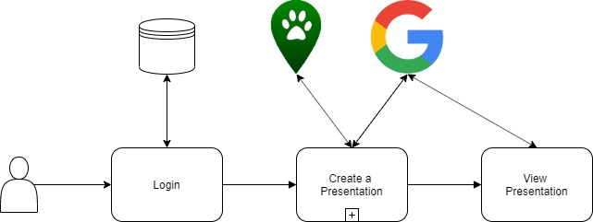
Figure 3 shows that the user will login, which Django will save the login info. We will then pull information from the application Ecolocation and sources from the Google Earth Engine API. The information is then formatted so that it fits for the right age group through the Google Slides API.

Conclusion
Making sense of large quantities of scientific data is difficult for anyone, especially school teachers who have many other duties and worries. We want to make it easy for them to access and translate information about their local environment into a teachable format for children and young adults. Environmental education has only grown more important as climate change looms more and more over our heads, and we want to ensure that the next generation is educated correctly on the matter.
Within this document, we tested the technologies we want to use to create this product:
- The programming language we’re going to use
- How we are going to integrate the previous capstone project, Ecolocation, as requested by our client
- How our software will utilize Ecolocation’s information to display static and animated graphs
- What Database software we will use
- What type of application we are going to develop
- What IDE the team will use to code the software

We tested multiple technologies and scored all of them based on our criteria, what our client has specifically requested, and where our priorities may lie. While we will continue to be on the lookout for potentially better solutions, this will be what we choose.

Category | Technology | Why We Chose It
Language | Python/Django | The features of Django and the readability of Python
Ecolocation Interaction | ArcGIS | It’s secure and it’s graphs are visually appealing for younger ages
Database Interaction | Amazon Web Service (AWS) | Our client requested it specifically and it’s very secure
Database Language | MySQL | AWS works well with it, and Ecolocation is written in it
Application Type | Web | Web is the most easily accessible to teachers.
Integrated Development Environment (IDE) | PyCharm | It has Python and Django integration as well as a steady learning curve

Resources
“Introduction to Google Drive API | Google Developers.” Google API, Google, https://developers.google.com/drive/api/v3/about-sdk?hl=en_US.
Aparicio, Sara. “A Golden Age for Earth Observation.” A Golden Age for Earth Observation, Medium, 5 Sept. 2017, https://medium.com/google-earth/a-golden-age-for-earth-observation-f8b281cec4b7.
Elmblad, Shelley. “How Is Desktop Software Different From an App?” The Balance, The Balance, 21 Nov. 2018, https://www.thebalance.com/what-is-desktop-software-1293673.
Rouse, Margaret. “What Is Web Application (Web Apps) and Its Benefits.” SearchSoftwareQuality, https://searchsoftwarequality.techtarget.com/definition/Web-application-Web-app#targetText=A Web application (Web app,all, websites contain Web apps.
“What is MySQL?” Amazon, Research Defence Society, 2007, https://aws.amazon.com/rds/mysql/what-is-mysql/.
“Database Concepts.” Overview of Application Development Languages, 10 Oct. 2005, https://docs.oracle.com/cd/B19306_01/server.102/b14220/data_access.htm.
“MySQL Documentation.” MySQL, https://dev.mysql.com/doc/.
Lindsay, John. “Welcome to the Whitebox GAT Project.” Whitebox GAT | Home, https://jblindsay.github.io/ghrg/Whitebox/.
“ArcGIS Online.” Arcgis.com, https://www.arcgis.com/index.html.
“Slides API | Google Developers.” Google, Google, https://developers.google.com/slides/.
“Earh Engine API | Google Developers.” Google, Google,
https://developers.google.com/earth-engine/api_docs
“Ruby on Rails.” Ruby on Rails, https://rubyonrails.org/.
“The PHP Framework for Web Artisans.” Laravel, https://laravel.com/.
“Django.” Django, https://www.djangoproject.com/.
“Best IDE Software - a List of the Top 10.” KeyCDN, https://www.keycdn.com/blog/best-ide.
“What is an IDE.” Red Hat, https://www.redhat.com/en/topics/middleware/what-is-ide. Accessed October 20, 2019.

